

| **TITLE**: Design and animate the following: Pendulum /Collision of object /Water waves |
| --- |

**AIM:**

Use the Blender software or any other open source software to create and animate or (Pendulum /Collision of object /Water waves)

**______________________________________________________________________**

**Expected OUTCOME of Experiment:**

Understanding of blender software.

**_____________________________________________________________________**

**Books/ Journals/ Websites referred:**

Youtube

**____________________________________________________________________**

**Steps to perform:**

1. Open blender
2. Make the object of plane
3. Make scale according to requirement
4. add dynamic paint
5. Select water paint
6. Select canvas
7. Make another object
8. Make brush
9. Start animation

**Drive or GitHub link:**

https://github.com/Aatmaj-Zephyr/ComputerGraphics/tree/main

**Output(s) (Screen Shots):**

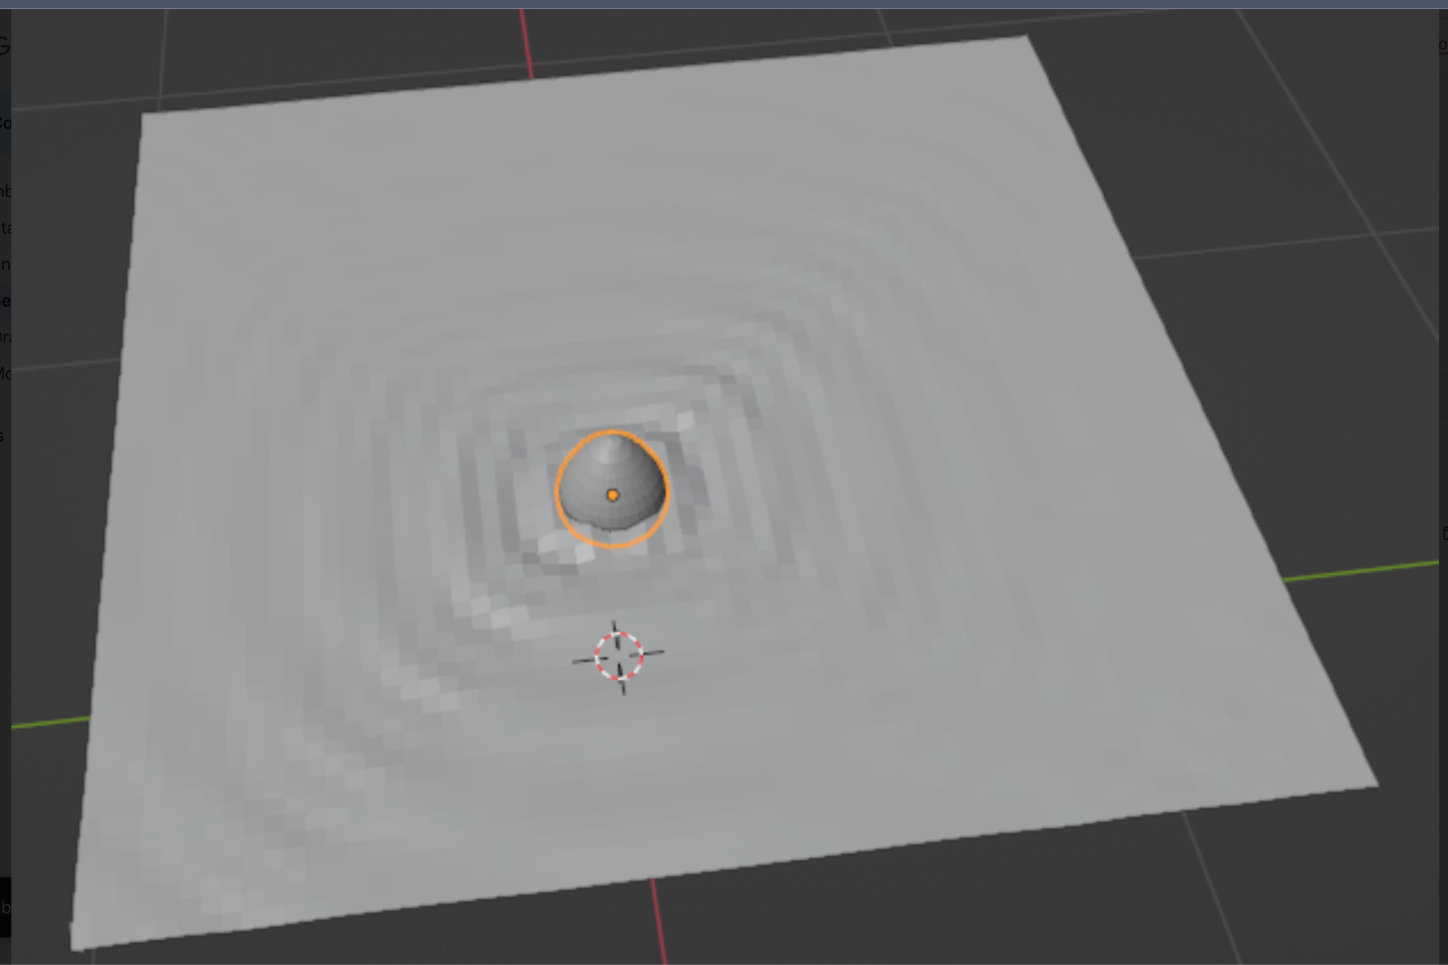

**Conclusion and discussion:**

Thus we have understood how to use blender software. We used dynamic paint to utilise the laws of physics to add water ripples to our surface. Blender is a image rendering tool that has the capacity to map the law of physics to make real-life images. We used it to make a water ripple. When the brush touches the canvas, it animates as a water ripple.

**Date: 27 Jul 2023**

**Signature of faculty in-charge**